**Expert ID/Name: Nstructive**

**Date: 11-Nov-2020**

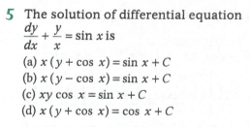

**Answer:**

|  |
| --- |
| MCQ Type Answers |

|  |
| --- |
| Choices |

|  |
| --- |
| Tips:  1.Integrating factor of  is .  2.  General solution of  is  .  4. |

|  |  |  |  |  |  |  |  |  |
| --- | --- | --- | --- | --- | --- | --- | --- | --- |
| Correct Answer: (c)  (c) Explanation  Given :  To find: General solution of  Step1:   |  |  | | --- | --- | | Instruction: | 1. .Integrating factor of  is .  2. | | Calculation: | Compare with |   Step 2:   |  |  | | --- | --- | | Instruction: | . General solution of  is | | Calculation: |  |   Final Answer: General solution of is . |